Header
Nav
About Dr Syakira
Services
Patient Testimonials
Contact Me
Main
About Me
Client testimonials
Health Blog
Link to third party review system
Booking appointment system
Footer
Contact details
IG page

Design language
- Modern
- Smooth transition
- Professional pictures with good clarity and bokeh
- Beige-white-cream with some tint of pink colour theme
- Semi-translucency
- Mobile-friendly
- https://thomasdigital.com/industry/best-doctor-websites

Security concerns
- GDPR-compliance
  - If you are taking in
- HTTPS
- .com domain
  - O&GbyDrSyakira
- Booking appointment system. Handled by 3rd party?
- DDOS
  - WAF filter
- SQL injection
  - Encryption
  - Limit privileges
  - Parameterize queries
- Dependency on third party webhosting

Font
- Garamond for Header
- Montserrat for paragraph

Style guide:
Color theme:
- More warm pink/peach.
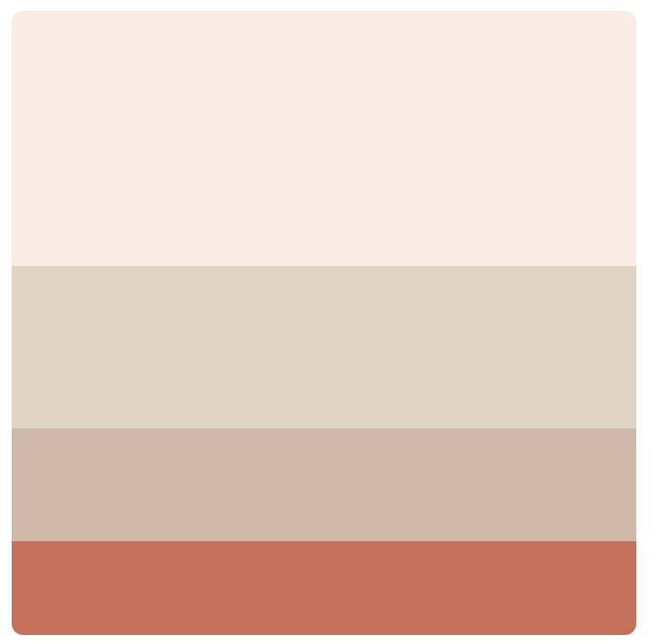
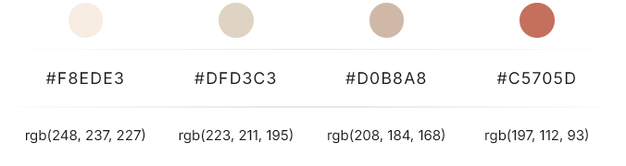
https://colorhunt.co/palette/f8ede3dfd3c3d0b8a8c5705d
first color for general background
second color for background of
third color for footer
fourth color for H1 and H2
Tiger Lily pink rgb(219,135,128) for Hover elements
Font
H1 ,h2
- Montserrat
- At least 20px;
- Font-weight: bold

P
- Lora
- Justified
- Black
footer
- Address
- Contact

Viewport:
- Desktop
- Tablet
- Mobile

